

**Tribhuvan University**

**Faculty of Humanities and Social Sciences**

**ONLINE VOTING SYSTEM**

**A PROJECT REPORT**

**Submitted to**

**Department of Computer Application**

**Nepal Mega College**

***In partial fulfillment of the requirements for the Bachelors in Computer Application***

Submitted by

Kalyan G.C

Reg no: 6-2-266-15-2022

Apeksha Dhungana

Reg no:6-2-40-110-2021

March, 2025

Under the Supervision of

**Mr. Basanta Chapagain**



**Tribhuvan University**

**Faculty of Humanities and Social Sciences**

**Nepal Mega College**

**Supervisor’s Recommendation**

I hereby recommend that this project prepared under my supervision by KALYAN G.C and APEKSHA DHUNGANA entitled “**ONLINE VOTING SYSTEM”** in partial fulfillment of the requirements for the degree of Bachelor of Computer Application is recommended for the final evaluation.

______________________

Mr. Basanta Chapagain

**SUPERVISOR**

Department of Computer Application

Babarmahal, Kathmandu



**Tribhuvan University**

**Faculty of Humanities and Social Sciences**

**Nepal Mega College**

**LETTER OF APPROVAL**

This is to certify that this project prepared by KALYAN G.C and APEKSHA DHUNGANA entitled “**ONLINE VOTING SYSTEM”** in partial fulfillment of the requirements for the degree of Bachelor in Computer Application has been evaluated. In our opinion it is satisfactory in the scope and quality as a project for the required degree.

|  |  |
| --- | --- |
| Mr. Basanta Chapagain  Lecturer, BCA  Department of Computer Application Babarmahal, Kathmandu | Mr.Dharma Raj Poudel  Coordinator, BCA  Department of Computer Application Babarmahal, Kathmandu |
| **Internal Examiner** | | **External Examiner** |

# ACKNOWLEDGEMENT

The project work presented in this report has been carried out and presented at Nepal Mega College, Faculty of Humanities and Social Sciences Tribhuvan University of Technology as a part of Bachelors of Arts in Computer Application. Project is a test of not only technical skills but also teamwork and performance under various constraints. This journey cannot be successfully accomplished without help from experts.

Furthermore, we would like to thank our lecturers of the Department of Computer Application for their kindness in sharing their knowledge with us which in different ways has helped us in coming up with this project and being there for us when we needed them, our friends who have always been there to support us and our respondents who gave us feedbacks on improving our project work.

We will be ever grateful to our supervisor **Mr. Basanta Chapagain**, Lecturer without whose guidance, this project would not have become successful.

We are also grateful to our department coordinator **Mr.Dharma Raj Poudel**.

Finally, our greatest appreciation and love goes to our families, friends and mentors and for sure this would not have happened without their unconditional love, care and support.

# ABSTRACT

Prevalent paper-based voting system has lots of cons as we have seen it being implemented for decades. First, it can be manipulated so easily and mistakes are so likely to occur. Secondly, the vote count might not be accurate enough as it’s done by humans. The ballots could be stolen or destroyed. It also requires lots of manpower and resources. As it is paper based it utilizes lots of paper which requires more effort for recycling and cleaning afterwards making it not so environmentally friendly.

So, the objective of this project is to review the existing system and overcome the possible flaws present in the current system by introducing another system, the Online Voting System. The main aim of this project has been to minimize the use of papers and human resources.

Hence the implementation of the system overcomes some of the major problems faced by paper-based voting systems. The problem of accessibility of existing systems is eliminated to some extent using the Online Voting System. It can be concluded that this system increases participation in elections. This system is built using PHP for the backend, MYSQL for database management, and HTML, CSS, and JavaScript for the front end.

***Keywords:*** *voting system****,*** *online voting system, paper ballots, e-voting,* *MySQL, PHP, HTML, CSS, JavaScript, DFD.*

ACKNOWLEDGEMENT III

ABSTRACT IV

LIST OF TABLES VI

LIST OF FIGURE VII

LIST OF ABBREVIATIONS VIII

Chapter 1: Introduction 1

1.1 Introduction 1

1.2 Problem Statement 2

1.3 Objectives 2

1.4 Scope 2

1.5 Limitation 2

1.6 Report Organization 3

Chapter2: Background Study and Literature Review 4

2.1 Background Study 4

2.2 Literature Review 4

Chapter 3: System Analysis and Design 6

3.1 System Analysis 6

3.1.2 Feasibility Analysis 8

3.1.3 Data Modeling using ER-Diagram 9

3.1.4 Process Modeling using DFD 9

3.2 System Design 11

3.2.1 Architectural Design 11

3.2.2 Database Schema Design 11

3.2.3 Interface Design (UI Interface / Interface Structure Diagrams) 12

Chapter 4: Implementation and Testing 14

4.1 Implementation 14

4.1.1 Tools Used (CASE tools, Programming languages, Database platforms) 14

4.1.2 Implementation Details of Modules 14

4.2 Testing 15

4.2.1 Test Cases for Unit Testing 15

4.2.2 Test Cases for System Testing 19

Chapter 5: Conclusion and Future Recommendations 21

5.1 Lesson Learnt / Outcome 21

5.2 Conclusion 21

5.3 Future Recommendations 21

References 22

# LIST OF TABLES

*Table 4.1Registration form* 15

*Table 4.2Login form* 16

*Table 4.3Testing Admin Dashboard* 17

*Table 4.4Testing voter/ candidate Dashboard* 18

*Table 4.5Testing Whole System* 19

# LIST OF FIGURE

Figure 3.1 *Waterfall model of Online Voting System* 6

Figure 3.2 *Use case of Online Voting System* 7

Figure 3.3*Gantt Chart of Online Voting System* 8

Figure 3.4*Online Voting System of ER Diagram* 9

Figure 3.5*Context Level Diagram of Online Voting System* 9

Figure 3.6*Level 1 DFD of Online Voting System* 10

Figure 3.7*Architectural Design of Online Voting System* 11

Figure 3.8*Database design of Online Voting System* 11

Figure 3.9*Registration Page* 12

Figure 3.10 *Login Page* 12

Figure 3.11*Admin Panel* 13

# LIST OF ABBREVIATIONS

|  |  |
| --- | --- |
| **CASE:**  **CSS:**  **DFD:**  **ER:**  **HTML:**  **ID:**  **OVS:**  **PHP:**  **PIN:**  **UI:** | Computer Aided Software Engineering  Cascading Style Sheets  Data Flow Diagram  Entity-Relationship  Hyper-Text Markup Language  Identity  Online Voting System  Hyper-Text Preprocessor  Personal Identification Number  User Interface |

# Chapter 1: Introduction

1.1 Introduction

Democracy grants every citizen the right to vote for choosing the head of the states. That means elections should be fairly conducted. Elections are must under democratic system which happens in business environments, educational environments, social organizations and in state’s governance. Paper-based voting systems in which everything was done with hands from casting to counting of votes, were in implementation in many states and organizations for conducting elections. Paper ballots are subject to be corrupted, malicious, manipulative and very high chance of occurrence of physical hazards. After that electronic tabulation was introduced in which voters cast votes manually but counted electronically and it is still in implementation.

All these traditional systems require more manpower for almost all the work such as for securely transporting paper ballots, counting votes, etc. so it is labor intensive and costly. Also, it might require training workshops on how to conduct fair elections or on how to cast votes in a proper way.

Online voting system allows voters to cast their votes without their physical presence rather from where they are with their devices connected to the internet. It is also referred to as I-voting, online election system or online e-voting. It is one of the levels of the e-voting system. Online voting is nothing but a secure voting tool that allows voters to cast a vote and view results. Online voting system just integrates the voting system with this era of information and technology. Everything done in past elections manually by hand could be digitized with the help of an online voting system. So, to overcome this and for paperless systems, an Online Voting System can be implemented. Online Voting requires nothing but a digital platform so it saves lots of resources and it is environment-friendly. Also, it is precise and consumes less time. It is secure and also provides security to the voters as one can cast votes from anywhere when connected to the system. It is a safe and secure collection of votes. As it is online, the need to gather in-person, cast votes using paper, etc. are overcome. Online voting can be implemented for electing organizational leaders, staff, for choosing company’s policy, for selections, etc. It is done through the web which means it guarantees more numbers of voters than in past elections conducted in a paper-ballot system so it increases voter-turnout. Mainly, it increases involvement of youth of the country in elections i.e., vital for the country's future.[1]

Therefore, there is a need of Online voting system where people can vote freely, feeling secure with very less chance of physical hazards. This project is mainly aimed to provide a convenient environment for the voters and to minimize the use of papers in elections by conducting it digitally. It is a web-based voting system with a secure interface to cast votes. In this project, a feasible online voting system is designed and implemented. Traditional electoral methods are simplified and digitized with information technology by saving human resources and time. In this system, citizens must be 18 years of age or above to be registered for being able to cast votes to be a voter. In this system, voters regardless of any race, gender, religion can cast their vote online without physical presence. Registration of the candidates are manually done by the system administrator whereas voters themselves fill the forms with their personal details and submit to the system. After the registration, voters are assigned username and password to sign in to the system for casting votes. Invalid log in details redirects users to the same login page where there is an option to register as a voter. In the system’s database names of all the voters are stored including their essential information.

1.2 Problem Statement

There are lots of drawbacks of both previous and present voting systems that require lots of human resource, time and money. And mainly it requires lots of paper and paperwork for registration, identification, authentication, etc. Also, there are malpractices in the elections which result in chaos and violence. Hence, there is a need to replace the current voting system with an online voting system which could overcome the cons of the previous system.

1.3 Objectives

The objectives of project are:

* To create a secured, accessible digital voting system.
* To display real-time vote counts and maintain transparency in voting.

1.4 Scope

This document describes the requirement analysis and designing of the system. The scope of the project has been to successfully develop a paperless online voting system which is environment friendly. The system can be used anytime from anywhere. Multiple votes from the same users can’t be casted. It is easier to use with a friendly interface.

1.5 Limitation

The authentication part of the system is not so professional. Function for specifying voting time is not present in the system.

1.6 Report Organization

The report can be organized into 5 chapters which are given below:

**Chapter 1** includes introduction includes the brief introduction of the system, statement of problem, objectives, scope and limitation.

**Chapter 2** includes background study and literature review includes the previous work related to the systems and similar works were studied and are summarized.

**Chapter 3** includes system analysis and design includes different feasibility analysis and designed system architecture, system flow diagram, data flow diagram.

**Chapter 4** includes implementation and testing including various implementation methods and tools and also contains description of testing.

**Chapter 5** includes conclusion and future recommendations includes outcomes of the system, conclusion to the system and description about what features can be added in the future.

# Chapter2: Background Study and Literature Review

2.1 Background Study

Democracy is a system of governance in which people have the authority to deliberate and decide legislation or to choose governing officials to make laws. In democracy the supreme power lies in the people. People choose their representatives in democracy through elections. Election is a major part of democracy of which voting is the core component. Election is a formal decision-making process by which a mass chooses individuals as their representation to hold the authority to govern and make legislature.

Paper-based voting system is a voting system in which ballots are used to cast votes. Ballots are papers or small balls used in secret voting. Online voting system is the modern way of voting using digital technologies like the internet and computers.

2.2 Literature Review

The existing system of election is running manually i.e., paper-ballot system. The Voter has to visit both to vote for a candidate so there is wastage of time. The voter has to manually register into the voter list. Vote counting has to be done manually. All the information of the voter or Candidate is to be filled in manually. Voters must be present physically to cast votes. Implementation of voting via the internet was tried but was not quite successful in designing a secure and efficient designing of voting system. Electronic voting was also used in elections in Estonia where the system included the use of smart cards and electronic signatures. There was an internet voting system that offered voting through different identification like ID card and PIN codes, Digital ID, Mobile numbers, etc.

Previously, many efforts have been carried out for developing an efficient online voting system for election purposes. There are various implementations of electronic voting systems around the world but it differs slightly from online voting systems as an electronic voting system may require human clerks tallying the votes upon termination of the election process as it uses biometrics and code voter cards. Paper ballots are the traditional tool used for voting. Paper ballots are usually punched or marked by a human and then tallied by machine. Paper ballots come at a much cheaper cost than electronic systems. They also reduce the attack surface on an election by removing the possibility of a soft-ware/hardware attack. Paper ballots rely on physical security and trust in the polling stations to not manipulate them and to properly handle them. When it comes time to cast a vote, the voter once again launches the application and logs in to the previously registered account. The application requests a ballot from the Ballot Regulator (via the application server). The Ballot Regulator checks Blockchain A for the requesting voter’s address, and ensures it is signed by the Verifier. If the address does exist on Blockchain A, then the Ballot Regulator sends the voter the appropriate regional ballot. The voter marks their responses. Before submitting the ballot, the voting application encrypts the vote using the Ballot Regulator’s Public Voting key.[2]

It is helpful to know if those that vote by paper are committed to that voting method, or if they would be willing to vote online in a future election. To get a sense of this willingness respondents were asked whether they would be inclined to vote online under particular circumstances. Forty-seven percent said they would use Internet voting in a future election under special circumstances such as in cases of illness, inclement weather, mobility issues, or because they were traveling. This speaks to both the convenience and accessibility of Internet voting as a remote voting method, which can make casting a ballot easier in institutions where an elector is not able to make it to the polls. About one-third (30 percent) of respondents said they would use Internet voting in future ‘no matter what’ and 16 percent commented they would not use it at all. While some paper voters are inclined to vote by Internet in a future election then, the majority of this group would elect to make use of the voting method under particular situations where they could not physically make it to a poll location.[3]

Hence, there are many efforts applied in the field of voting systems and many organizations & countries has adopted it but most of them are not web-based online voting systes.

# Chapter 3: System Analysis and Design

3.1 System Analysis

Requirement collection provides detailed analysis of user requirements, functional & non-functional requirements and system requirements. The front-end is done using HTML & CSS whereas in back-end JavaScript is used for Client side and PHP for Server side. MySQL is used for Database programming.

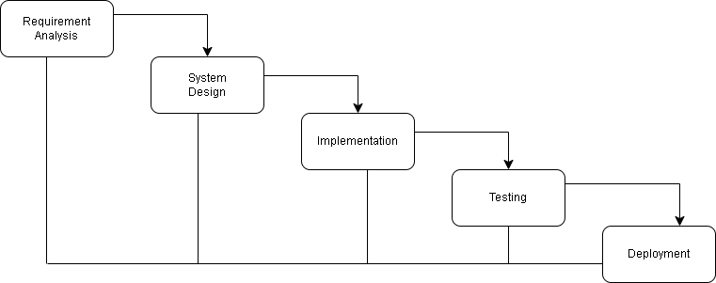

**Figure 3.1 *Waterfall model of Online Voting System***

The waterfall Model was the first process model to be introduced. It is also referred to as a linear-sequential life cycle model. It is very simple to understand and use. In a waterfall model, each phase must be completed before the next phase can begin and there is no overlapping in the phases. It is easy to arrange tasks and clearly defined stages.  
3.1.1 Requirement Analysis

**i. Functional Requirement:**

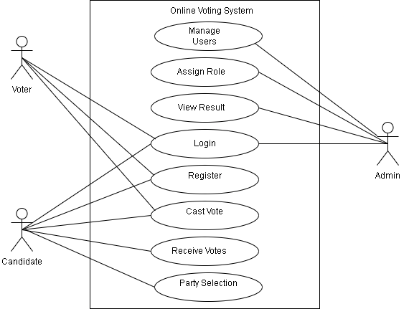

**Figure 3.2 *Use case of Online Voting System***

The use case diagram represents the requirement of the system comprising use cases, voters, admin and their relationships. This use case diagram shows functional requirements of the system between admin and the user when registered as a voter. When registered as a voter, he/she can login to cast a vote to the candidate. Candidates can receive votes and select a party. Admin looks after the overall management of the system. To cast a vote, one must register, unregistered users can’t cast a vote. User logins to the system by entering valid user id and password. Users can cast a vote only once after they login and the same credentials can’t be used to cast a vote. User logs out of the system after casting the vote.

**ii. Non-functional Requirement:**

The system has a form-based interface for data entry and stores reports formatted in a table and for user friendliness. The system has reasonable short time response. The system has good performance as response time is short. The system doesn’t crash in the middle of the process as it is reliable. System can be considered secure as only the admin can view the user's information.

### 3.1.2 Feasibility Analysis

**i. Technical Feasibility**

Since the project is designed with PHP as code behind and MySQL as backend it is easy to install in the systems whenever needed. It is more efficient, easy and user friendly to understand by almost everyone. Huge amount of data can be handled efficiently using MySQL as the backend. Hence this project has good technical feasibility.

**ii. Operational Feasibility**

The system is operationally feasible as it provides enough response and throughput time. Also, manpower to operate this system is easily available.

**iii. Economic Feasibility**

Economic feasibility is mainly concerned with the cost incurred during their implementation of the software. Since the project is developed using PHP and

MySQL which is more commonly available and free. Similarly, it is to recruit persons for operating the software. Since almost everyone is aware of PHP and MySQL. Even if we want to train the person in these areas, the cost involved in training is also very less. Hence this project has good economic feasibility.

**iv. Schedule Feasibility**

The time required to complete the project is calculated and classified using the following Gantt Chart:

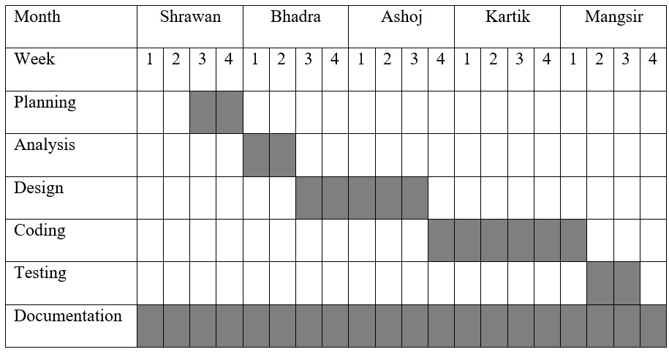

**Figure 3.3*Gantt Chart of Online Voting System***

### 3.1.3 Data Modeling using ER-Diagram

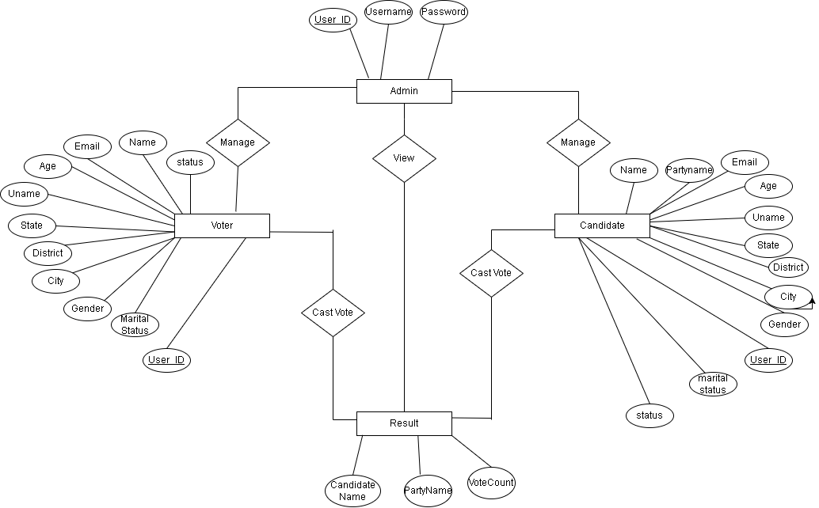

**Figure 3.4*Online Voting System of ER Diagram***

This model shows entities, relationships between entities, mapping and the entity relationship models. User provides all the required information and gets a role. When assigned a voter, he/she can cast a vote. When assigned a candidate he/she is assigned a party. Vote count gets the number of casted votes along with party name, voter info and provides it to result which can be viewed by admin.[4]

### 3.1.4 Process Modeling using DFD

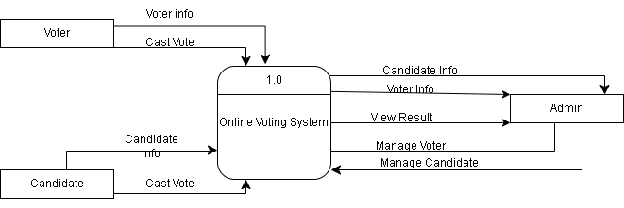

**Figure 3.5*Context Level Diagram of Online Voting System***

Users need to register in the system and should provide their information to get a role. Candidates and Voters both can cast votes. Admin manages all users and can

view the result.

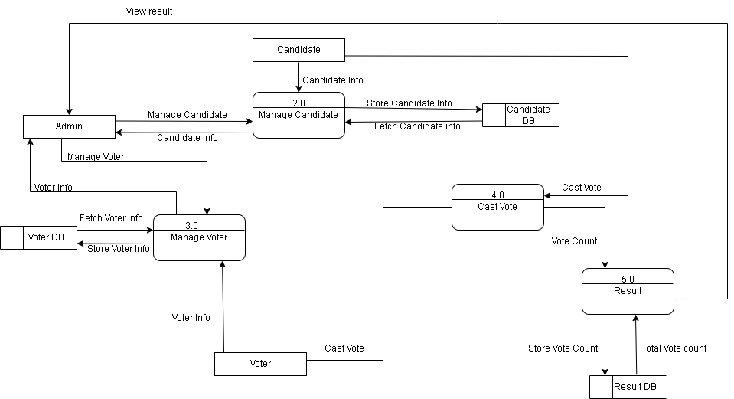

**Figure 3.6*Level 1 DFD of Online Voting System***

DFD is an abstract description of the system. DFDs are in levels which represent increasing information flow and functional detail. User chooses a role either as a voter or a candidate. All the registration votes and voting details are stored in the database. As the admin manages elections, he/she manages voters and candidate information too. System generates results which can be viewed by admin.[5]

3.2 System Design

### 3.2.1 Architectural Design

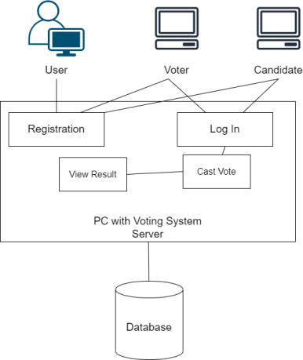

**Figure 3.7*Architectural Design of Online Voting System***

Users take roles as either voter or candidate during registration who then login into the system to cast the vote which are stored in the database.

### 3.2.2 Database Schema Design

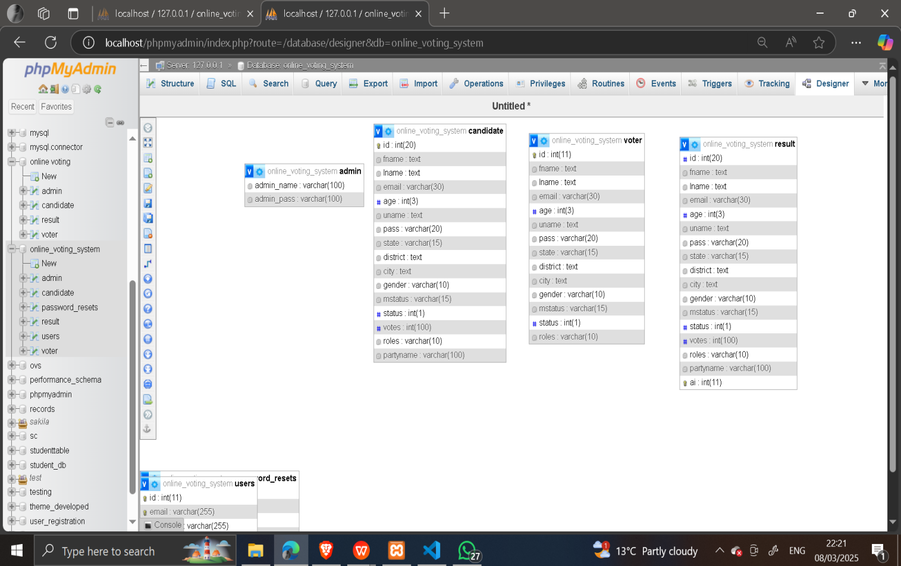

**Figure 3.8*Database design of Online Voting System***

The database of the Online Voting System is maintained with 4 tables as per the ER diagram. As every candidate is a voter, id of voter is assigned as primary key whereas other id in other tables is referenced to it.

### **3.2.3 Interface Design (UI Interface / Interface Structure Diagrams)**

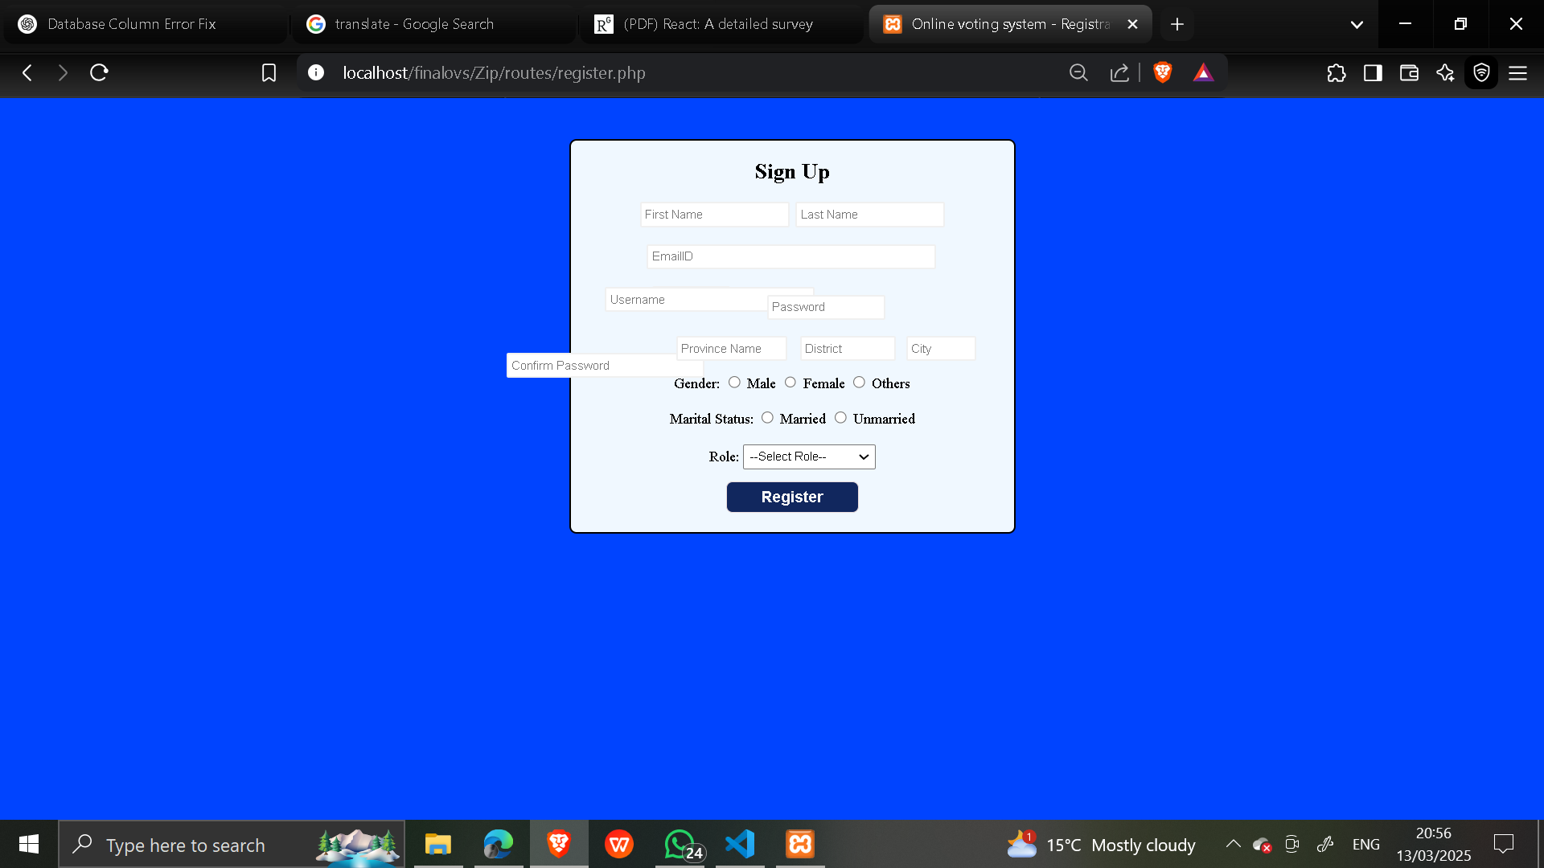

**Figure 3.9*Registration Page***

Here is the interface design of the registration page. Text Box, Radio Button- and Drop-Down lists are used in registration form.

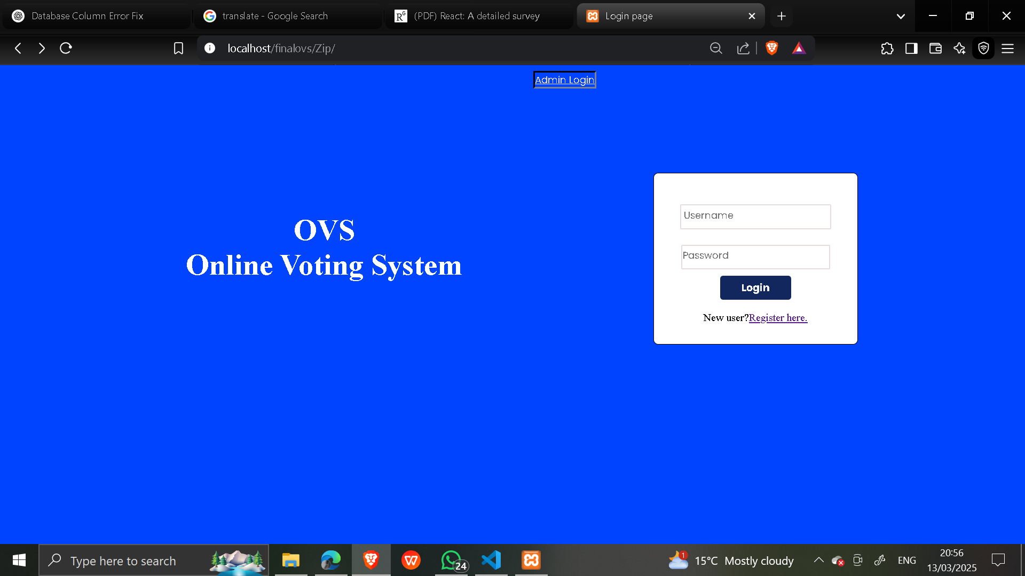

**Figure 3.10 *Login Page***

This is the main page of the system from which the user logs in or goes to the registration page. It contains a Text Box, Button, etc.

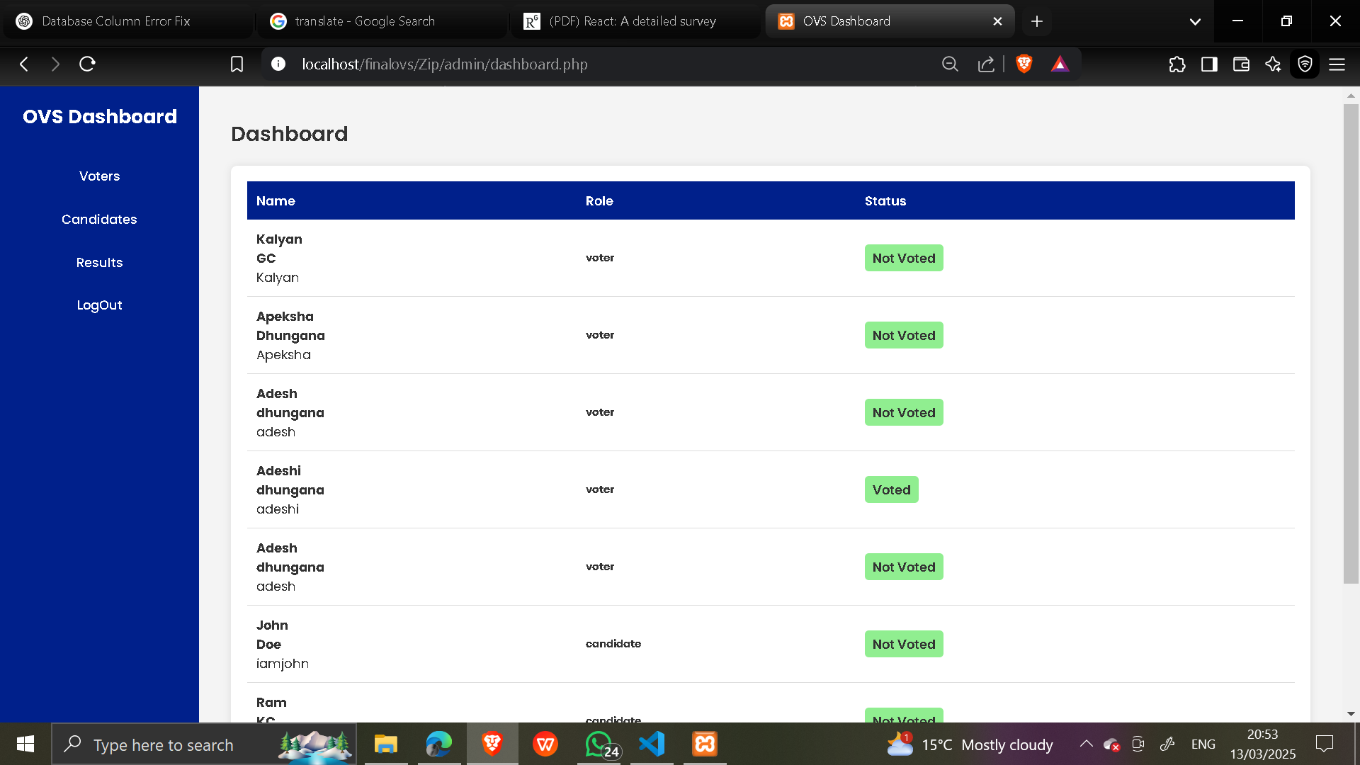

**Figure 3.11*Admin Panel***

This is the Admin’s dashboard of the system from which it manages voters and candidates and also views results from the list of menus in the left side of the page.

# Chapter 4: Implementation and Testing

4.1 Implementation

The implementation phase involves the application of the design specifications done before. The implementation involves coding of the system designs if this project, systems testing and live running.

### 4.1.1 Tools Used (CASE tools, Programming languages, Database platforms)

Diagramming tools such as draw.io, lucid chart and dia were used for graphical representation of the data and systems. These were used to make flowcharts, DFD, ER diagrams, Gantt Charts, etc. MSWord was used for the documentation. Visual Studio Code was used to write, edit and compile the codes. PHP, JavaScript, CSS, HTML was used to build the webapp. XAMPP was used to host the webapp. MySQL was used to design the database for data storage.

### 4.1.2 Implementation Details of Modules

**User Registration**: Users have to register into the system before they can cast votes. Users are required to fill the registration form with text boxes, radio buttons for user information, dropdown list for role and party selection. User can choose two roles while registering:

i. As a Voter: When selecting a Voter from the dropdown menu in role, he/she is assigned the role of voter.

ii. As a Candidate: When a user selects Candidate from the dropdown menu in role, he/she is allowed to choose the party. After selecting the party name, they can proceed to get the role of candidate

To be able to register into the system one must be at least 18 years old.

**User login**: Users are required to login to the system after only complete registration. Users are only able to login in the system with the username and password they registered their account with.

**Cast Vote**: Any user either voter or candidate logged in into the system is able to cast their vote to their favorite candidate. They can cast a vote as soon as they login to the system through the voting dashboard.

**Admin Dashboard Panel**: Admin after logging in can edit or delete user’s details or the users themselves through the admin dashboard.

**View Result**: Admin logged into the system can see the vote count of every candidate from the dashboard.

**User logout**: User is automatically signed out of the system after casting their vote. So, the same user can’t cast multiple votes.

4.2 Testing

### 4.2.1 Test Cases for Unit Testing

The system comprises registration form, login form, admin dashboard, voter/candidate dashboard and for each case unit testing is done.

***Table 4.1Registration form***

|  |  |  |  |  |  |
| --- | --- | --- | --- | --- | --- |
| Test Case  Name | Test Case Description | Step | Expected  Result | Actual Result Test | Result |
| Registration Form  Password  validation | Input  unmatched password | Input  unmatched password | Display message  “Password  And Re-enter password  must match.” | Display  message  “Password  and Re-enter password  must match.” | Pass |
| Registration Form email validation | Email  validation | Input  email | If same email alert display message  “Email  already  exists.” | Message  displayed  “Email  already  exists.” | pass |
| Registration Form  validation | Provide  valid  username password email | Provide  valid  username password email | Display alert message  “Registered  Successfully” | Display alert message  “Registered Successfully” | **pass** |

|  |  |  |  |  |  |
| --- | --- | --- | --- | --- | --- |
| Test  Case  Name | Test  Case  User | Test Case Description | Step | Expected  Result | Actual  Result |
| Validate  Login | Admin | Enter valid username,  email and password | Choose  User type Admin  Enter  username, email and password | Login  Successful or an error message  “Invalid  credentials” must be  displayed. | Successful  Login  Directed to Admin  dashboard. |
| Validate  Login | Voter/Candidate Enter valid | email and password | Enter  email and password | Login  Successful or an error message  “Invalid  credentials” must be  displayed. | Successful  Login  Directed to Voting  Dashboard. |
| PREVIEW | To check  if the  admin,  candidate  and voter  will be  able to  visit their  respective dashboard | Enter  valid  username em ail and password | Successfully Visit their  own  dashboard | Successfully Visit their  own  dashboard |  |

***Table 4.2Login form***

|  |  |  |  |  |  |
| --- | --- | --- | --- | --- | --- |
| Test  Case  Name | Test Case  Description | step | Expected  Result | Actual  Result | Test  Case  Status  Pass/Fail |
| Edit Voter | Edit  selected  Voter data | Click on  manage  Voter and then click edit to edit selected  Voter | Display  form to edit Voter details and then Updated  successfully message  should be  displayed | Updated  successfully | Pass |
| Delete  Voter | Delete  selected  Voter date | Click on  manage  Voter and then click delete to  delete  selected  voter | Delete  selected  Voter  details | Deleted  successfully | Pass |

***Table 4.3Testing Admin Dashboard***

|  |  |  |  |  |  |  |  |  |
| --- | --- | --- | --- | --- | --- | --- | --- | --- |
| Candidate | | Edit selected candidate  data | | Click on  manage  candidate and then  click edit to edit selected candidate | Display form to edit  candidate  details and then Updated successfully message  should be  displayed | Updated  successfully | | Pass |
| TC 10 Delete Candidate | | Delete  selected  candidate  data | | Click on  manage  candidate  and then  click delete to delete  selected candidate | Delete  selected  candid ate  details | Deleted  successfully | | Pass |
| 5. TC 11 Logout | To exit from the dashboard | | Click on  logout | | Direct to index page | Directed to index page | Pass | |

***Table 4.4Testing voter/ candidate Dashboard***

|  |  |  |  |  |  |
| --- | --- | --- | --- | --- | --- |
| Test Case  Name | Test Case  Description | Step | Expected  Result | Actual  Result | Test  Case Stat  us  Pass  /Fail |
| View  Candidates | View  candidates in election | Log in | Display  candidates | Displayed  candidate | Pass |
| Cast Votes | Cast vote to candidate | Click on  vote | Increase  Vote count | Increase  Vote count | Pass |
| View votes | View vote counts | Select  candidate | Display  total vote s received | Display  total votes received | Pass |
| Logout | To exit  from the  dashboard | Click on  logout | Direct to  index page | Directed to index page | Pass |

### 

### 4.2.2 Test Cases for System Testing

After unit testing, the whole integrated system is tested for security, usability, regression, recovery and migration.

***Table 4.5Testing Whole System***

|  |  |  |  |  |  |
| --- | --- | --- | --- | --- | --- |
| Test  Case Name | Test  Case  Descript  ion | Step | Expected  Result | Actual  Result | Test  Case  status  Pass/  Fail |
| Security Testing | Checking Security to access  system | Login with your  Registered username and  password | Successful Login  Directed to User  Dashboard . | Successful  Login  Directed to User  dash board. | Pass |
| Security Testing | Checking Security to access  system | Try Login  with  unauthorized email and  password | An error  message  “Invalid credentials” must be  Displayed. | An error  message  “Invalid  credentials” displayed . | Pass |
| Usability Testing | Eliminate Duplicate email data on  registration | User  Registration with already available email | Message  Display ed  “Email  Already exists.” | Message  displayed  “Email  already  exists.” | Pass |
| TC 19 Usability Testing | User casting vote | User casting vote | Vote casted | Vote casted | Pass |
| TC 20 Usability Testing | Cast  multiple  vote | Try casting vote twice  Form the same username | Error  message  displayed . | Error message displayed. | Pass |
| TC 21 Usability Testing | Admin  managing  user detail | Admin  managing user detail | Admin  managing  user detail | Admin  managing user detail. | Pass |
| Testing | Testing  Load of  system | For demo test we have  added 5 voters and 4  candidates | System  performs  well | System  performs well | Pass |
| TC 23 Regression Testing | Testing new bugs during the  development and  changes | Development and changes on code. | Bugs found and solved | Bugs found and solved | Pass |
| TC 24 Recovery testing | Input  Recovery testing | Updating user detail | User detail Updated | User detail Updated | Pass |
| TC 25 Migration testing | Migrating System to an other  PC | Migrating  System to  Another PC. | System  works  successfully | System works successfully | Pass |

# Chapter 5: Conclusion and Future Recommendations

5.1 Lesson Learnt / Outcome

The expected outcome of the project is an online voting system with a user-friendly interface which is a secure and paperless system superior to the previous voting system.

5.2 Conclusion

The system lets users select roles at the time of registration either as a voter and candidate. Also, all the users both voter and candidate, can cast votes by logging into the system and choosing their favorite candidate.

5.3 Future Recommendations

The system implemented was to showcase better alternative ways to conduct elections mainly focusing on reducing paper wastage which was the major problem of the paper-based voting system and the work was limited to this extent but there are other issues to be solved.

There are lots of other flaws in the voting system which need to be solved. Security of the system can be implemented in a better way. Transparency control can be maintained in the system letting different users view different perspectives. Event control which lets to schedule the specific time of election could be added in the future.

# 

# References

|  |
| --- |
| 1. A. a. P. D. Anand, " "An efficient online voting system."," *International Journal of Modern Engineering Research,* pp. 2631-2634, 2012. 2. G. O. a. E. P. Ofori-Dwumfuo, "The design of an electronic voting system," *Research Journal of Information Technology,* vol. 3.2, no. 2, pp. 91-98, 2011. 3. T. J. D. Y. a. J. P. F. Teorey, " "A logical design methodology for relational databases using the extended entity-relationship model."," *ACM Computing Surveys (CSUR) ,* vol. 18.2, no. 3, pp. 197-222, 1986. 4. R. a. S. Y. Y. Ibrahim, ""An automatic tool for checking consistency between Data Flow Diagrams (DFDs)."," *World Academy of Science, Engineering and Technology 69 (2010),* vol. 2, no. 4, p. 69, 2010.   [5] D. P. K. K. R. a. S. R. S. Mishra, "Modern tools and current trends in web-development.," *Indonesian Journal of Electrical Engineering and Computer Science,* vol. 24.2, no. 5, pp. 978-985, 2021. |

# Appendices

**Dashboard Screen**

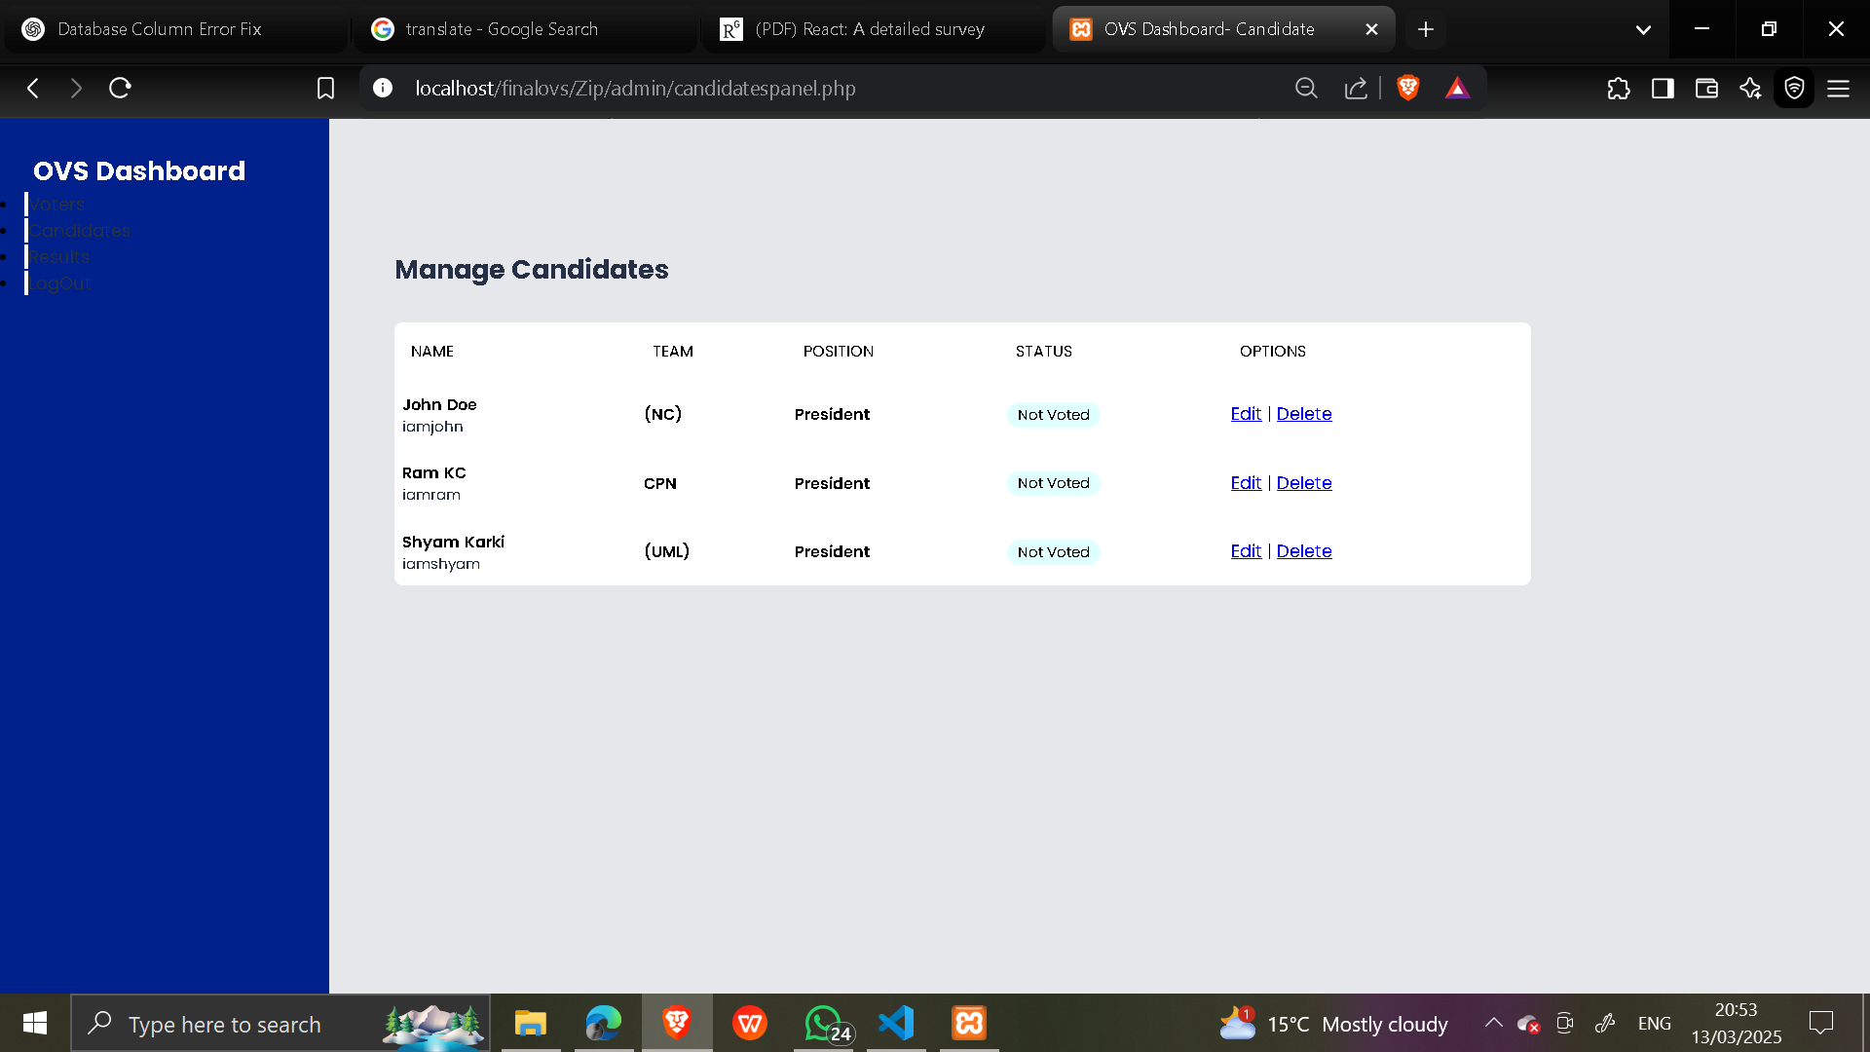



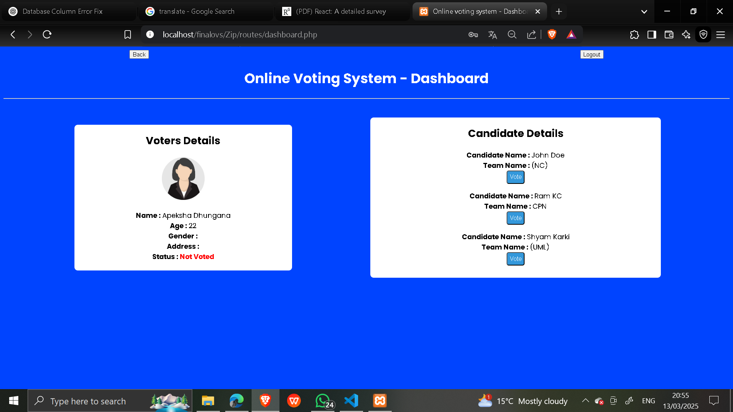

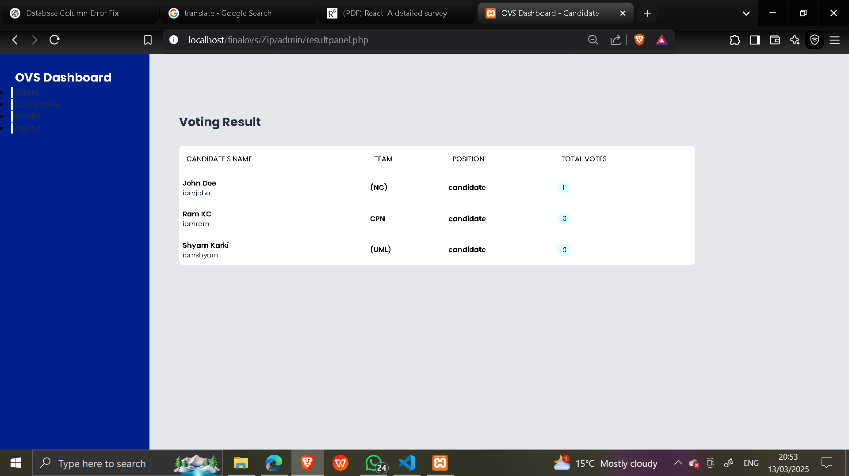

**Sign Up Screen**

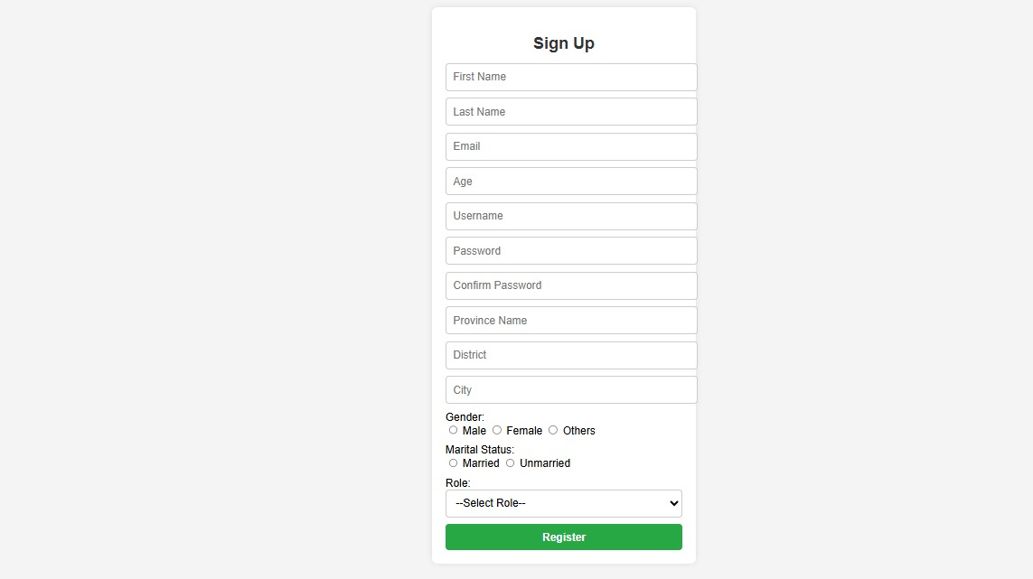

**Administration Login Screen**

